**Server and Repository Management :**

1. Repository Management
   1. In the whole project, I am responsible to pull and merge all members commit before push new updates to Heroku server. Which include merger the conflict, improve and debug team members tasks. As the result, I am team members who make most commit and write most lines on code in overall project. 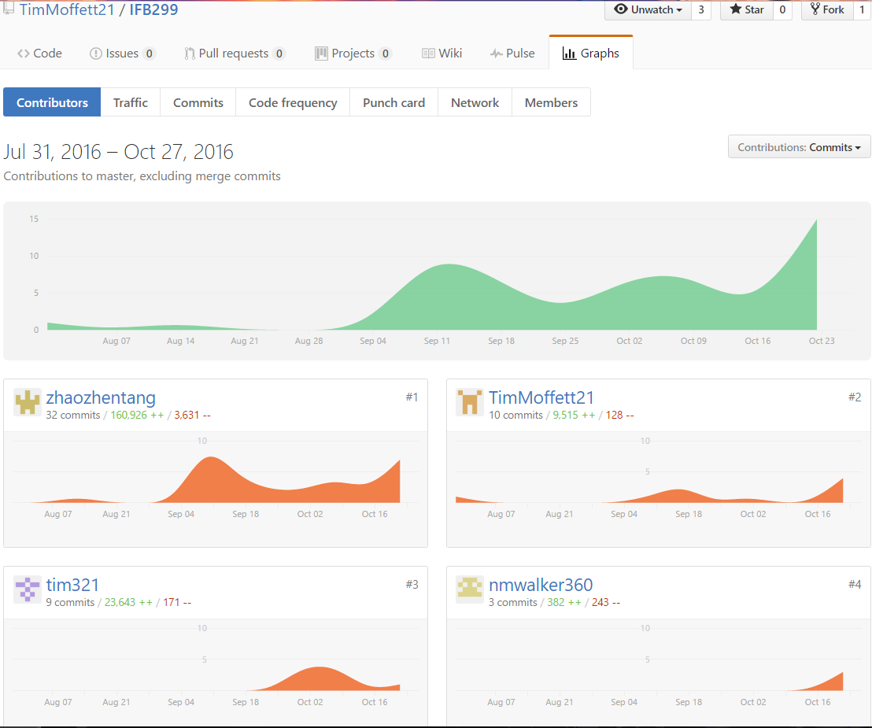

Contributors contribution chart in our GitHub Project Repository

* 1. I’m helping team members when they facing problem in manage GitHub, mostly on pull, merge , commit and push their updates to GitHub.

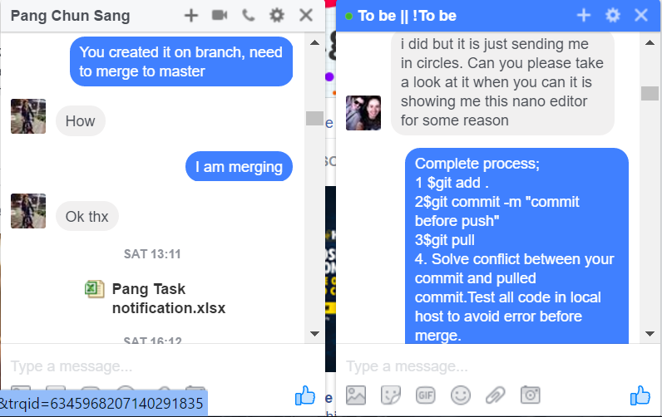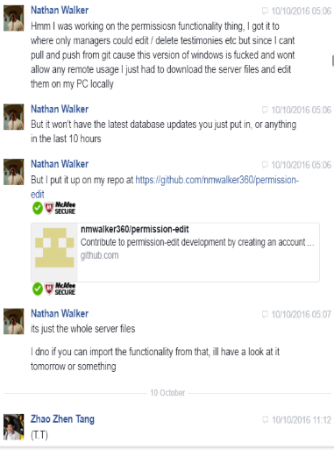

Proof of assist friends in Github Management.

1. Server Management :

In the whole project, I am responsible to create and manage server of our website, On The Spot Package Delivery Website. I am able to help my friend through Cloud9 IDE which allow users to share their IDE access to other team members.

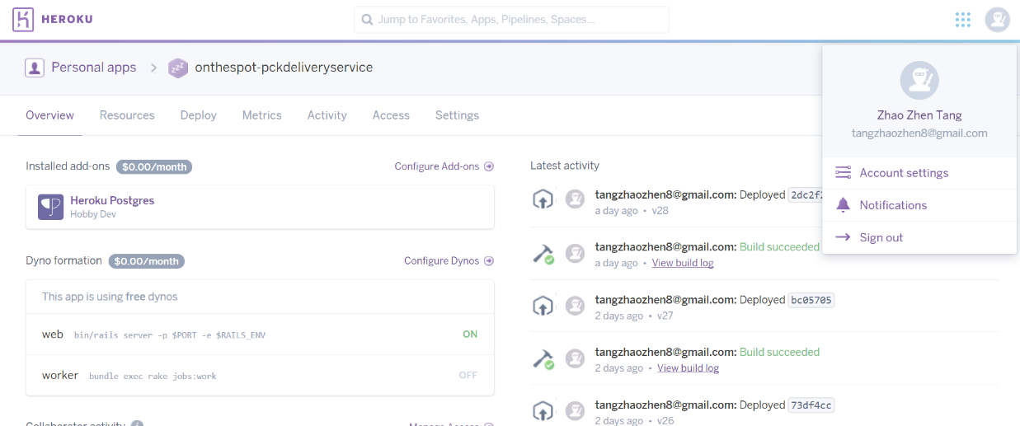

Zhao Zhen Tang On The Spot Delivery Details Page on Heroku Website.

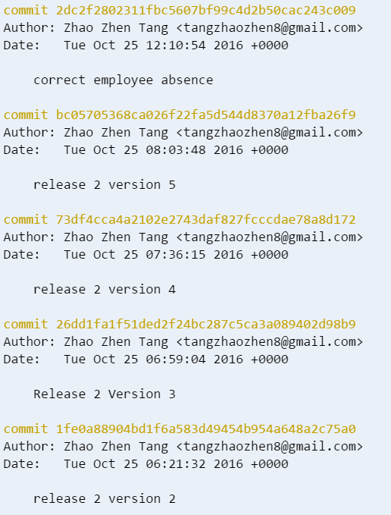

Evidence of Pushing Updates to Heroku